Department of Information Technology
Faculty of Computing
The Islamia University of Bahawalpur



Software Design Document

ML-Based Intelligent WhatsApp Assistant for University FAQs Using Twilio Integration and Backend Automation

Submitted by
Muhammad Jamshaid Naseem
F22BINFT1M01014

Submitted to
Sir Abdul Karim Nawaz

Summary
This project develops an ML-based WhatsApp assistant capable of answering university-related queries through natural conversation. The system leverages Twilio’s WhatsApp API to receive messages from users. It routes them to a backend server integrated with a machine learning model trained on frequently asked questions (FAQs) about the university. The model intelligently interprets and responds to student inquiries such as admission details, course offerings, or campus facilities. Responses are automatically sent back to users on WhatsApp, providing a smart, real-time communication channel between the university and its students.

Table of Content

1. Introduction 4
1.1. Purpose of SDD 4
1.2. Scope 4
2. Application Architecture 4
2.1. Architectural Overview 4
2.2. High-Level Architecture Components 5
2.3. Architecture Flow 6
3. User Interface Design 6
3.1. UI Overview 6
3.2. User Interaction Flow 6
3.3. Sample UI Conversation 6
3.4. UI Design Characteristics 7
4. Design Diagrams 7
4.1. Architecture Diagram 7
4.2. Sequence Diagram 8
4.3. Component Diagram 8
4.4. Workflow Diagram 9
4.5. Security Diagram 9
5. Scalability and Maintainability 10
6. Conclusion 10

- Introduction
  - Purpose of SDD
This Software Design Document describes the internal design and structure of the ML-Based Intelligent WhatsApp Assistant for University FAQs. It translates the requirements defined in the SRS into a detailed technical design that guides implementation, testing, and maintenance.

  - Scope
The SDD covers:
- Overall application architecture
- Backend and ML model design
- Data model schema
- User interface design (WhatsApp-based interaction)
- System design diagrams and workflow explanation

- Application Architecture
  - Architectural Overview
The system follows a modular client–server architecture with ML-based intelligence at its core.
Key architectural layers:
- WhatsApp Client (User Interface)
- Twilio WhatsApp API Gateway
- Backend Server (Python)
- Machine Learning Engine
- Data Storage Layer
Each component operates independently but communicates through well-defined APIs.

  - High-Level Architecture Components
- WhatsApp Client

  - Users interact using the WhatsApp application.
  - No separate UI installation is required.
  - Messages are sent as plain text.

- Twilio WhatsApp API

  - Acts as a communication bridge between WhatsApp users and backend.
  - Receives incoming messages and forwards them to the backend server.
  - Sends responses back to users.

Backend Server (Python)

  - Built using Flask / FastAPI.
  - Handles:
    - Incoming webhook requests
    - Text preprocessing
    - ML model inference
    - Response formatting
    - Conversation context handling

Machine Learning Engine

- Supervised ML model trained on university FAQ data.
- Uses:
  - Text preprocessing (tokenization, stopword removal)
  - Vectorization (TF-IDF or embeddings)
  - Classification or similarity matching
- Predicts the most relevant response for a given query.

Data Storage Layer

- Stores:
  - FAQ dataset
  - Pre-trained ML model
  - Conversation logs (optional)
- Can use:
  - CSV / JSON (small-scale)
  - SQLite / MongoDB (scalable option)

  - Architecture Flow
- The user sends a message via WhatsApp.
- Twilio receives the message.
- Twilio forwards the message to the backend webhook.
- Backend preprocesses the text.
- ML model analyzes and predicts the response.
- Backend formats the response.
- Twilio sends the response back to WhatsApp.

- User Interface Design

  - UI Overview
The system does not have a traditional graphical interface.
WhatsApp itself serves as the user interface, making the system highly accessible.

  - User Interaction Flow
- The user opens WhatsApp.
- The user sends a text query (e.g., “What are admission requirements?”).
- The system replies instantly with an accurate answer.
- Users may ask follow-up questions.

  - Sample UI Conversation
User:
What courses are offered in Computer Science?
System:
The university offers BS, MS, and PhD programs in Computer Science.
For details, visit the official website or contact admissions.

  - UI Design Characteristics
- Simple and intuitive
- No learning curve
- Works on any device supporting WhatsApp
- Supports real-time communication

- Design Diagrams

  - Architecture Diagram

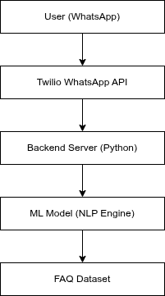

  - Sequence Diagram

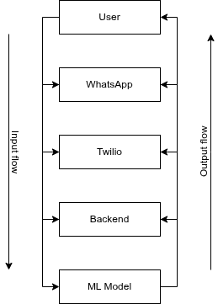

  - Component Diagram
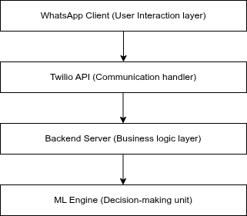

  - Workflow Diagram
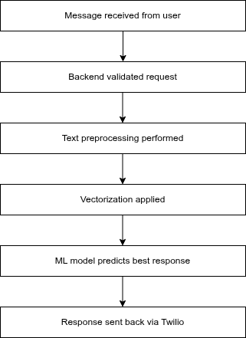
  - Security Diagram
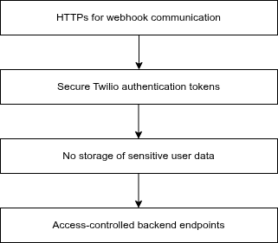

- Scalability and Maintainability

- Modular architecture allows easy upgrades
- ML model can be retrained independently
- FAQ dataset can be expanded without code changes
- Backend supports concurrent users

- Conclusion
This SDD provides a complete technical blueprint for implementing the ML-Based Intelligent WhatsApp Assistant for University FAQs. The design ensures scalability, maintainability, security, and ease of use while meeting all requirements defined in the SRS.

